**set** set 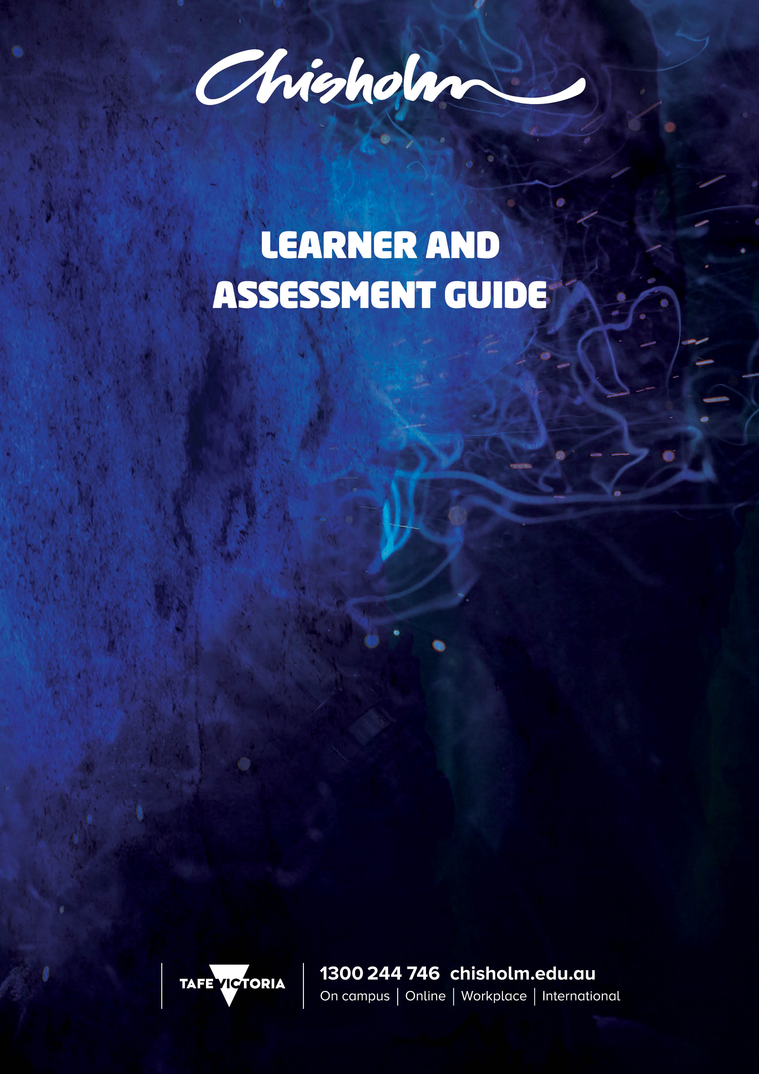

**CHC52015 Diploma of Community Services**

**CHCCCS007 - Develop and implement service programs**

**TITLE  
 COURSE CODE**

Cluster title if applicable

**UNIT/S CODE AND TITLE**

© Chisholm Institute 2018

*All requests and enquiries regarding use and availability should be directed to:  
Teaching and Learning, Chisholm Institute, PO Box 684 Dandenong VIC 3175,*

*Telephone: +61 3 9212 5000.*

*This work is copyright. Apart from any fair dealings for the purposes of private study, research, criticism or review, or as permitted under the Copyright Act, no part should be reproduced, transmitted, stored, communicated or recorded by any process, without written permission.*

*Any enquiries regarding copyright or permissions for reproduction must be made to Chisholm Institute.*

*All images courtesy of:* [*www.shutterstock.com*](http://www.shutterstock.com) *unless otherwise specified*

CONTENTS

INTRODUCTION 3

SCHEDULE SUMMARY 3

SCHEDULE OVERVIEW 3

LEARNING MATERIALS & RESOURCES 5

ASSESSMENTS 5

FACILITIES AND RISK CONTROL PLAN 7

# **INTRODUCTION**

This learner and assessment guide is designed to present a clear pathway of your learning and assessment journey for the associated unit/s. The schedule summary outlines the planned time frame and assessment points and is further described in the Schedule Overview. All relevant information such as resources required, planned activities and assessment tasks are included. If additional support is required, please refer to your course guide for further information or contact your teacher.

The table below describes the planned learning progression and assessment schedule of your course.

* X indicates the planned start duration and finish period for each of your units.
* Critical assessments for your unit/s is indicate using the following assessment key

**Key  
O**: Observation, **Q**: Questioning, **T**: Test/Quiz, **P:** Presentation, **E**: Portfolio of evidence,   
**R**: Report Essay, **PR** Project, **TP**: Third Party Report,

# **SCHEDULE SUMMARY**

| **Cluster title: If applicable** | **Sessions** | | | | | | | | | |
| --- | --- | --- | --- | --- | --- | --- | --- | --- | --- | --- |
| Unit code and title | 1 | 2 | 3 | 4 | 5 | 6 | 7 | 8 | 9 | 10 |
| CHCCCS007 - Develop and Implement Service Programs | X | X | X | X (Q) | X | X | X | X (Q) | X | X |

| **Cluster title: If applicable** | **Sessions** | | | | | | | | | |
| --- | --- | --- | --- | --- | --- | --- | --- | --- | --- | --- |
| Unit code and title | 11 | 12 | 13 | 14 | 15 | 16 | 17 |  |  |  |
| CHCCCS007 - Develop and Implement Service Programs | X | X | X | X (PR) | X (PR) | X (PR) | X (PR) |  |  |  |

# SCHEDULE OVERVIEW

|  |  |  |  |
| --- | --- | --- | --- |
| Week/Session  - # | Learning | Performance | Assessment |
| 1 | Introduction to Unit and Assessments | Housekeeping  Overview of assessments and requirements |  |
| 2 | Investigate the needs of individuals for service planning and delivery | What are the needs  How can the needs be identified |  |
| 3 | Collaborate and consult with other services and networks | Networking  Stakeholders  Partnerships and how to access these |  |
| 4 | Program development – Documents | What resources are needed to start and develop programs | **Assessment 1 Due** |
| 5 | Program development – Engaging a client group and meeting the client's needs | What are the needs of the client?  How can programs be developed to cater for this need? | Start working on Assessment 3 |
| 6 | Program development – Required resources | How to source the required resources  Funding applications |  |
| 7 | Program development – Implementing timelines and responsibilities | Timelines, tasks and planning |  |
| 8 | Determining roles and responsibilities with other stakeholders | Networking with stakeholders and partners and working with them in implementing services | **Assessment 2 Due** |
| 9 | Equipping facilitators to run the service/program delivery | The knowledge and skills of facilitators  Interpersonal skills |  |
| 10 | Monitor service delivery | Evaluation and the progress of programs |  |
| 11 | Evaluate and review program delivery | How to develop evaluation  Types of evaluations |  |
| 12 | Group Work Sessions | Working on projects | **Working on AT3 in class** |
| 13 | Group Work Sessions | Working on projects | **Working on AT3 in class** |
| 14 | Project presentation to Class Focus Group | Working on projects | **Working on AT3 in class** |
| 15 | Project presentation to Class Focus Group | Presentations on projects and evaluation | **Working on AT3 in class** |
| 16 | Group Work Sessions | Working on projects | **Working on AT3 in class** |
| 17 | Group Work Sessions / Subject Evaluation | Finalisation and submission of projects | **Working on AT3 in class** |

# LEARNING MATERIALS & RESOURCES

The following learning resources will be required by each student to use and practice skills to develop competency in the unit. Practical tasks may require the student to have purchased particular items, whilst Chisholm Institute will provide other resources to the learner.

The following information outlines the resources required to complete the learning and assessment tasks and identifies what the student needs to bring for each session.

|  |  |
| --- | --- |
| **Learning Resources** | **Materials Required** |
| **Resources** | Own pen, paper for note taking |
| **Digital Resources** | 1. Access to computer with internet  2. Moodle access  3. Printer and consumables |
| **Activities** | As provided by teacher |
| **Visuals** | As provided by teacher |
| **Handouts** | As provided by teacher |

# ASSESSMENTS

The following assessments will be used to collect evidence of the knowledge and skills you have gained from your Learning Program. You will be required to demonstrate your ability to perform to the standard required in the workplace, as specified within the assessment task criteria as detailed below:

|  |  |
| --- | --- |
| Assessment Tasks | Session |
| 1 – Questioning – Service Programs Questions | Session 4 |
| 2 – Questioning – Service Programs Questions | Session 8 |
| 3 – Project – Community Services Sector Program | Session 14-17 |

REQUIREMENTS

**Please read the following instructions about your assessment. They will help you to achieve the level of performance required for a successful assessment.**

**Please read all assessment instructions to ensure you are clear and fully understand the requirements as outlined in each task.**

To achieve competence in the unit/s a learner must meet requirements for all assessment tasks listed before a judgment of competency can be made. Where competency is not achieved your assessor will provide feedback and request further evidence as needed.

It is important that you clearly understand all the requirements of assessment. If you have difficulty with the assessment terms or the steps to follow please speak to your Assessor/ instructor prior to commencing the task/s. Your Assessor will provide additional information to ensure all aspects of the tasks are clear.

The specific assessment instructions for each task will be provided in the Assessment Guide for this unit/s. General information about assessment methods used for this unit are outlined below:

**Questioning**:

You will be provided with, or verbally asked, a series of questions related to the unit of competency undertaken in your course. The questions are used to assess you level of knowledge in relation to various aspects of the unit/s. Questioning may occur during an observable task where skills and knowledge are integrated.

**Presentation**:

A presentation may be oral, electronic using PowerPoint or similar, a visual display of work, a demonstration of a task or combination of different processes that may be interactive. The purpose of a presentation is to assess your ability to communicate within a team environment or present information in a public forum. The process will include research or knowledge development prior to the actual presentation.

**RE-ASSESSMENT**

If you do not achieve the required standard to achieve competence, you will be given the opportunity to be re-assessed by the assessor and the requirement for additional evidence will be outlined. Arrangements will be made on an individual basis to ensure the process is valid, fair and reliable.

**ASSESSMENT APPEALS**

A student who is dissatisfied with the outcome of his/her assessment should first discuss their concerns with the teacher/assessor and/or program coordinator in the associated business area. If the issue is not resolved, the student may appeal the decision(s) by following the Complaints and Appeals process as outlined in the Chisholm Student Guide.

# FACILITIES AND RISK CONTROL PLAN

It is essential that all assessment tasks are conducted at appropriate locations with safe working equipment and adequate facilities, following all relevant legislation, policies and procedures.

The following items identify the location of organisational policies and procedures identifying safe work practices for all learning and assessment activities and are underpinned by federal, state or local government legislation.

Please ask your trainer/assessor for a copy of the QMS document should further information be required.

|  |  |
| --- | --- |
| Description of item | Organisational Process |
| Student induction | QMS106 |
| Practical Placements | QMS109 |
| Emergency Management | QMS401 |
| First Aid | QMS402 |
| Hazard Management | QMS405 |
| Manual Handling | QMS408 |
| Electrical Safety | QMS413 |
| Workplace inspections | QMS418 |
| Work environment | QMS422 |

The following information describes the facilities where training and assessment is conducted, and the risk management processes in place to ensure safe working practices for students and assessors.

|  |  |  |  |
| --- | --- | --- | --- |
| Description of item/task | Hazard | Risk Rating | Control |
| Triggers through content | Triggers | Low | Teacher to provide support |
| Content | Issues with disclosures | Low | Teacher to provide support |

